Name: Vikash Mishra

Reg No.: RA1811003010344

Experiment: Best First Search

Statement : Best first search is a traversal technique that decides which node is to be visited next by checking which node is the most promising one and then check it. For this it uses an evaluation function to decide the traversal.

Algorithm: Start with the source in the priority queue and take out vertex with the smallest edge weight.

Code:

from queue import PriorityQueue

v = 14

graph = [[] for i in range(v)]

def best_first_search(source, target, n):

visited =[0]*n

pq=PriorityQueue()

pq.put((0,source))

while pq.empty()==False:

u=pq.get()[1]

print(u,end=" ")

if u==target:

break

for v,c in graph[u]:

if visited[v]==0:

visited[v]=1

pq.put((c,v))

print()

def addedge(x, y, cost):

graph[x].append((y, cost))

graph[y].append((x, cost))

addedge(0, 1, 3)

addedge(0, 2, 6)

addedge(0, 3, 5)

addedge(1, 4, 9)

addedge(1, 5, 8)

addedge(2, 6, 12)

addedge(2, 7, 14)

addedge(3, 8, 7)

addedge(8, 9, 5)

addedge(8, 10, 6)

addedge(9, 11, 1)

addedge(9, 12, 10)

addedge(9, 13, 2)

source = 0

target = 9

best_first_search(source, target, v)

Output:

1

Calculations:

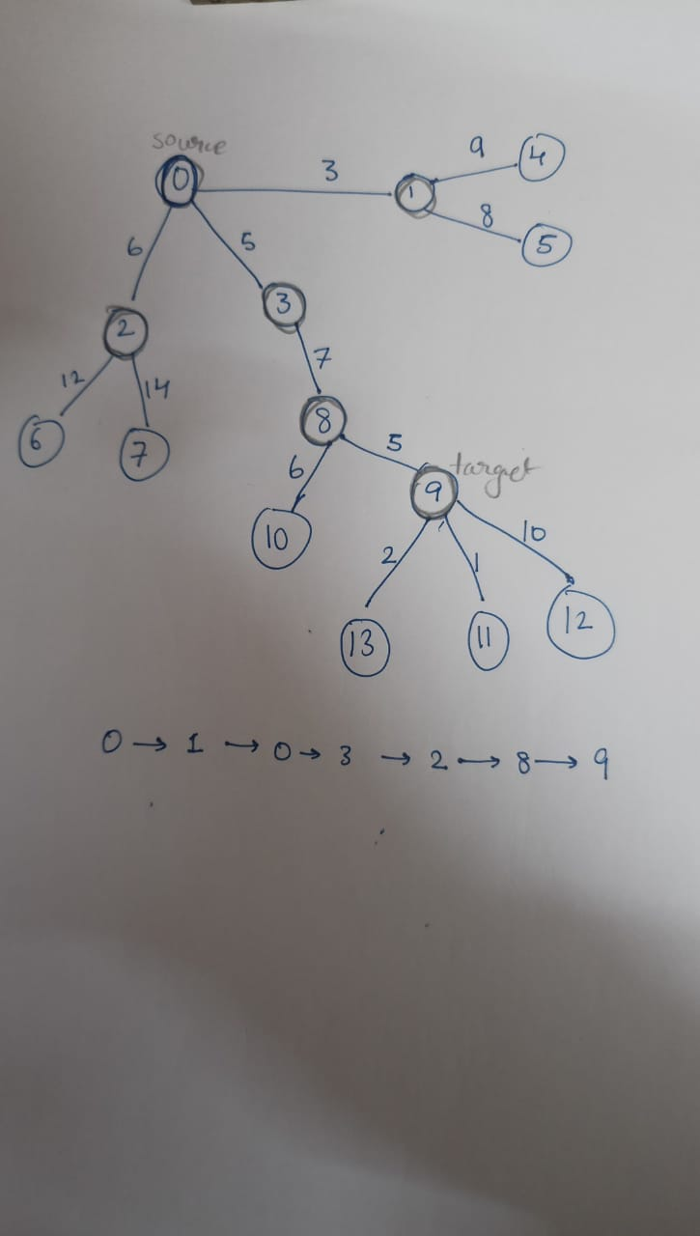

Result: Best first search was implemented using python programming and output was verified